I
n this session we will go through script task.

Why should I use scripts?
With the extended scripting support it is easy to prototype complete processes including the business logic. Also the sharing of such prototypes is simple, because the whole code can be embedded inside the process. So only one file has to be exchanged and discussed. In combination with the BPMN model API it allows you to create mock processes with business logic directly inside your code.

Script task
Another advantage is that now also non-Java programmers can use camunda BPM to execute their processes without writing Java code. Or if you already have an non-Java code base you can now use it inside camunda BPM without porting it to Java.
We also allow you to reuse scripts by using the camunda:resource attribute. Which loads scripts from external resources. Either the scripts can be part of your deployment or reside in the classpath of your application.

Script support in BPMN
The following table provides an overview of the BPMN elements which support the execution of scripts.

BPMN Element | Script Support
Script Task | Script inside the script task
Processes, Activities, Sequence Flows, Gateways and Events | Script as an execution listener
User Tasks | Script as task listener
Sequence Flows | Script as condition expression of a sequence flow
All Tasks, All Events, Transactions, Subprocesses and Connectors | Script inside an inputOutput parameter mapping

Script Task

A Script Task is an automated activity. When a process execution arrives at the Script Task, the corresponding script is executed.
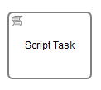

A Script Task is defined by specifying the script and the Script Format.
Supported script formats are Groovy, JavaScript, JRuby and Jython.

All process variables can be accessible through the execution.
execution.getVariable("variable name");
It’s also possible to set process variables in a script.
execution.setVariable("variable name","value");
Information can be accessed through execution’s default variable.
execution.eventName
execution.activityId
task.name
task.eventName

Exercise:
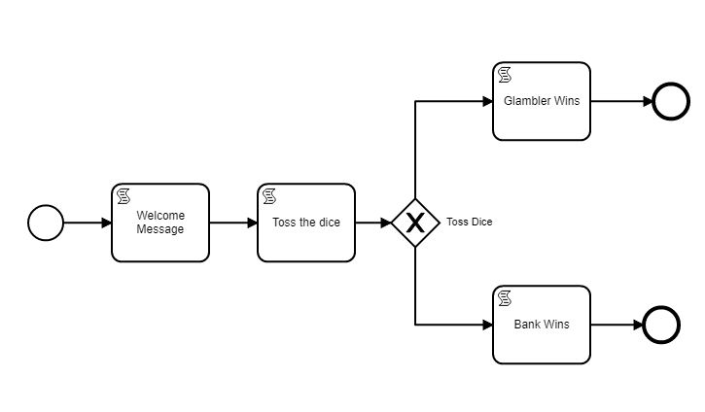

Setting properties for script each task:
Script task: Welcome Message
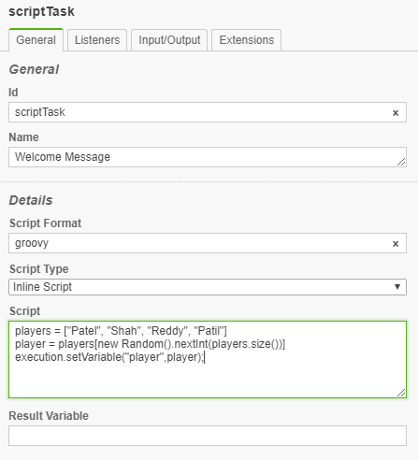
Script Format: groovy
Script Type: Inline Script
Script:
players = ["Patel", "Shah", "Reddy", "Patil"]
player = players[new Random().nextInt(players.size())]
execution.setVariable("player",player);

Script task: Toss the dice

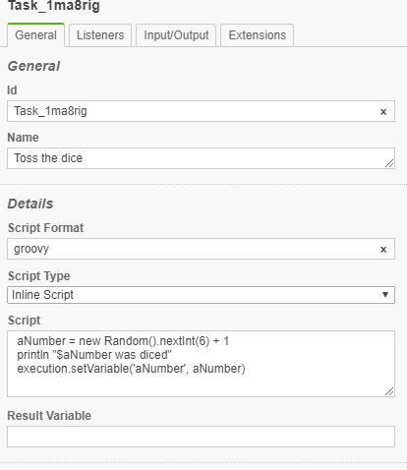

Script Format: groovy
Script Type: Inline Script
Script:
aNumber = new Random().nextInt(6) + 1
println "$aNumber was diced"
execution.setVariable('aNumber', aNumber)

Sequence Flow 1:
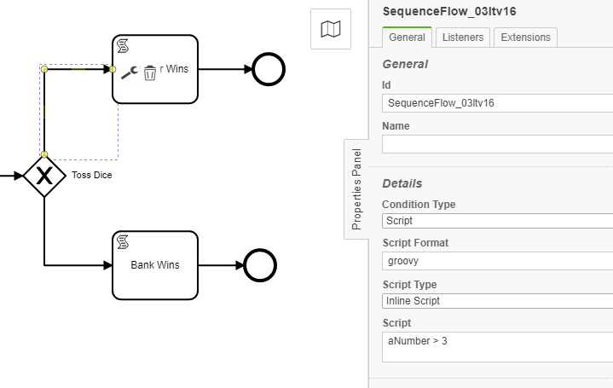

Script Format: groovy
Script Type: Inline Script
Script: aNumber > 3

Sequence Flow 2:
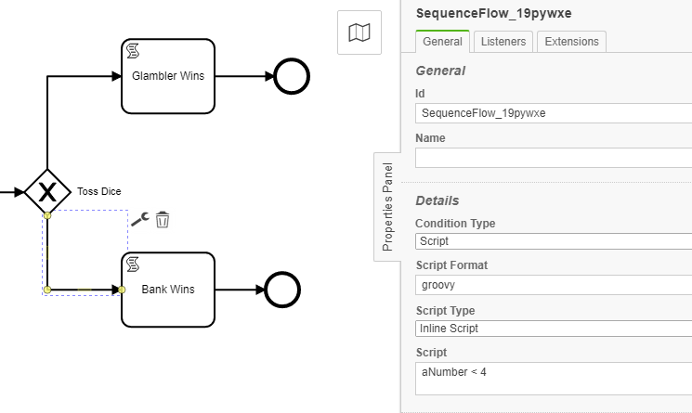

Script Format: groovy
Script Type: Inline Script
Script: aNumber < 4

Script task: Glambler Wins
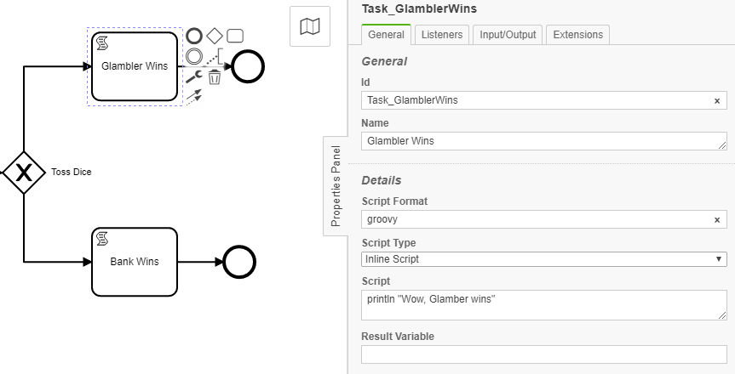

Script Format: groovy
Script Type: Inline Script
Script:
println "Wow, Glamber wins"

Script task: Bank Wins
Script Format: groovy
Script Type: Inline Script
Script:
println "Wow, Bank wins"

Deploy the process through Camunda modeler.
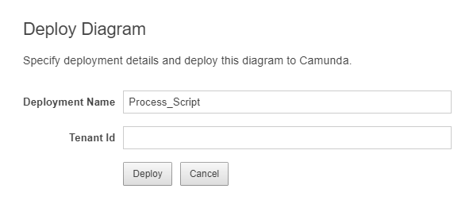
Start the deployed process multiple times from Camunda Tasklist application.

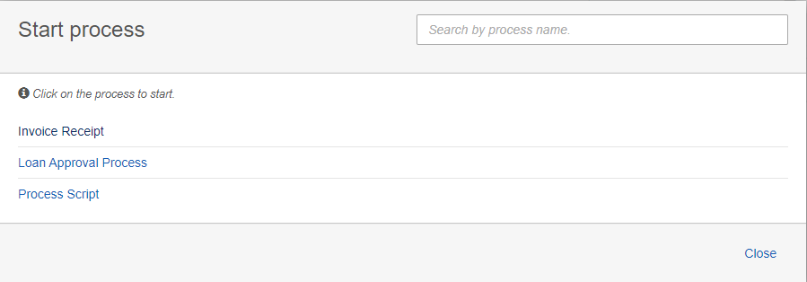

Check the console output:
Wow, Glamber wins
Wow, Glamber wins
Wow, Glamber wins
Wow, Bank wins
Wow, Bank wins
Wow, Glamber wins
Wow, Glamber wins

Script Result
The return value of a Script Task can be assigned to a previously existing or to a new process variable by specifying the process variable name as a literal value for the camunda:resultVariable attribute of a Script Task definition. Any existing value for a specific process variable will be overwritten by the result value of the script execution. When a result variable name is not specified, the script result value gets ignored.

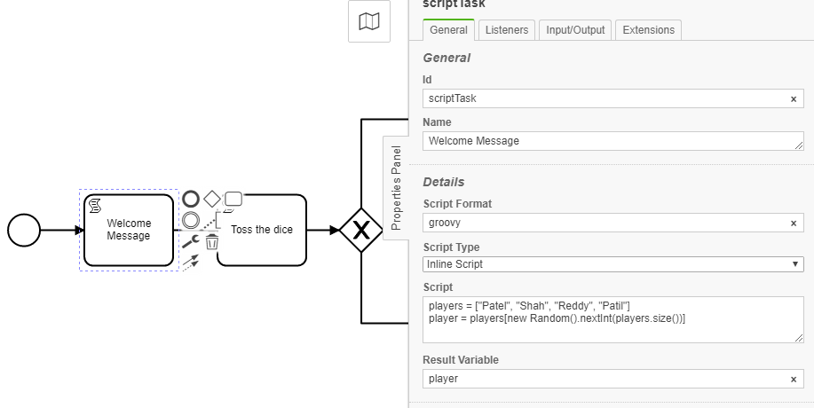

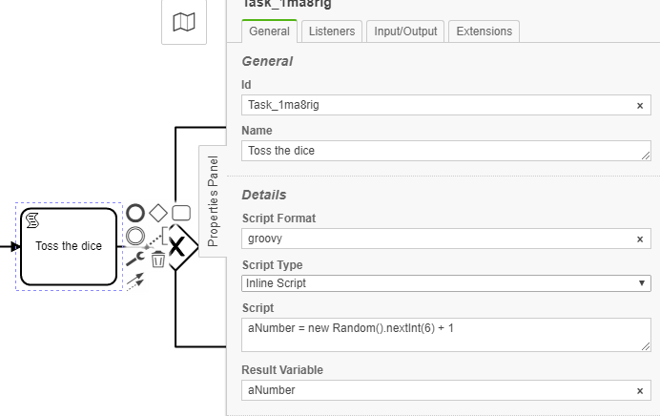

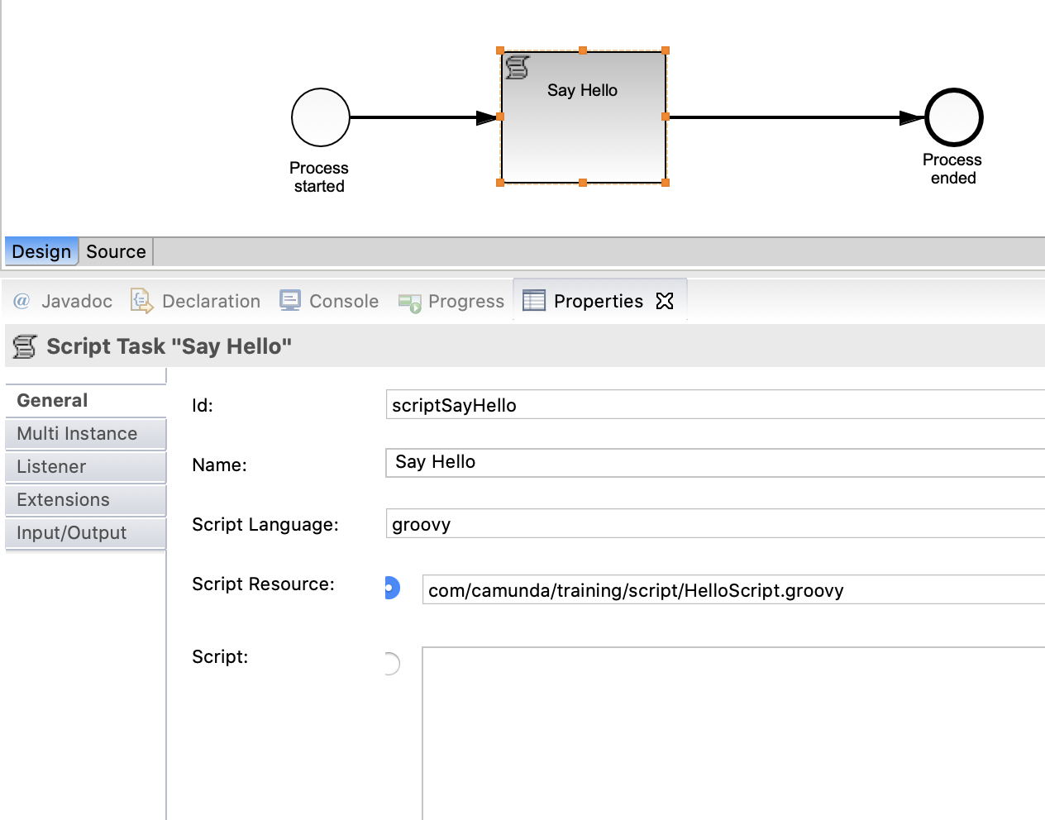
So far we have used inline script. Now let’s use external script.

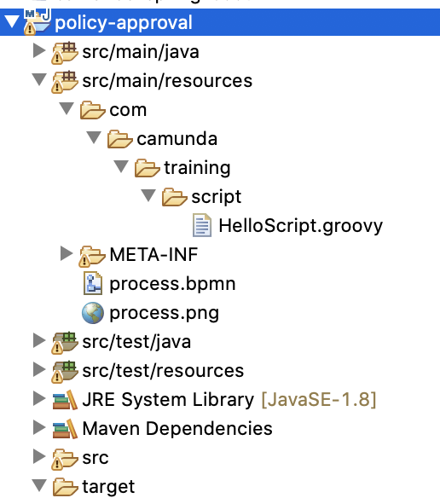
Create HelloScript.geoovy in resources/com/camunda/training/script directory.

Where to uses script:
Use Scripts as Execution Listeners
Use Script as Task listeners
Use Script as Conditions
Use Script as InputOutput parameters

Variables Available During Script Execution
During the execution of scripts, all process variables visible in the current scope are available. They can be accessed directly by the name of the variable (i.e., sum).

There are also special variables:
- execution, which is always available if the script is executed in an execution scope (e.g., in a script task) (DelegateExecution).
- task, which is available if the script is executed in a task scope (e.g., a task listener) (DelegateTask).

Execution Variables:

execution.activityInstanceId
execution.businessKey
execution.currentActivityId
execution.currentActivityName
execution.currentTransitionId
execution.eventName
execution.id
execution.processBusinessKey
execution.processDefinitionId
execution.processInstanceId
execution.tenantId

Execution methods:
execution.setVariable(variableName, value);
execution.getVariable(variableName)

Script:
Script format: groovy
Script:
out.println "Execution instance id : "+execution.activityInstanceId
out.println "Business key : "+execution.businessKey
out.println "Current activity id : "+execution.currentActivityId
out.println "Current activity name : "+execution.currentActivityName
out.println "Current transition id : "+execution.currentTransitionId
out.println "Event name : "+execution.eventName
out.println "Execution id : "+execution.id
out.println "Process business key : "+execution.processBusinessKey
out.println "Process definition id : "+execution.processDefinitionId
out.println "Process instance id : "+execution.processInstanceId
out.println "Tenant id : "+execution.tenantId

Task Variables:

task.assignee
task.caseExecutionId
task.caseDefinitionId
task.caseInstanceId
task.caseDefinitionId
task.createTime
task.deleteReason
task.description
task.dueDate
task.eventName
task.executionId
task.followUpDate
task.id
task.name
task.owner
task.priority
task.processDefinitionId
task.processInstanceId
task.taskDefinitionKey
task.tenantId

Task methods:

task.setVariable(variableName, value);
task.getVariable(variableName)

External Script
The script source code can also be loaded from an external resource.
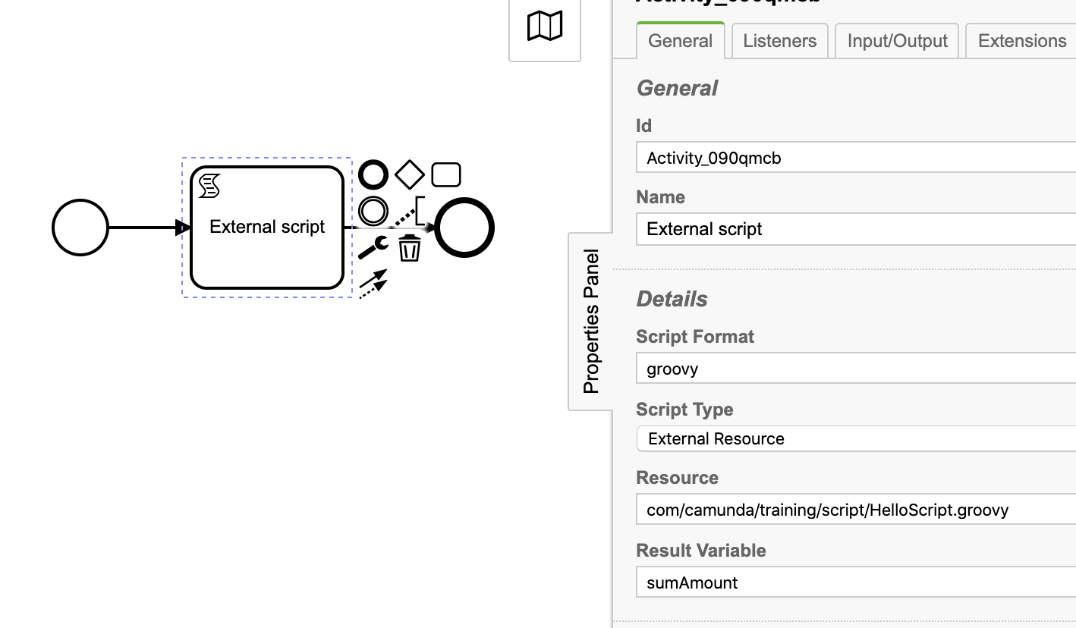

Copy HelloScript.groovy to camunda-bpm-tomcat-7.14.0/server/apache-tomcat-9.0.36/webapps/camunda/WEB-INF/classes/com/camunda/script/HelloScript.groovy

HelloScript.groovy

println "External Script called";
number1 = execution.getVariable("number1");
number2 = execution.getVariable("number2");

totalAmount = number1 + number2

